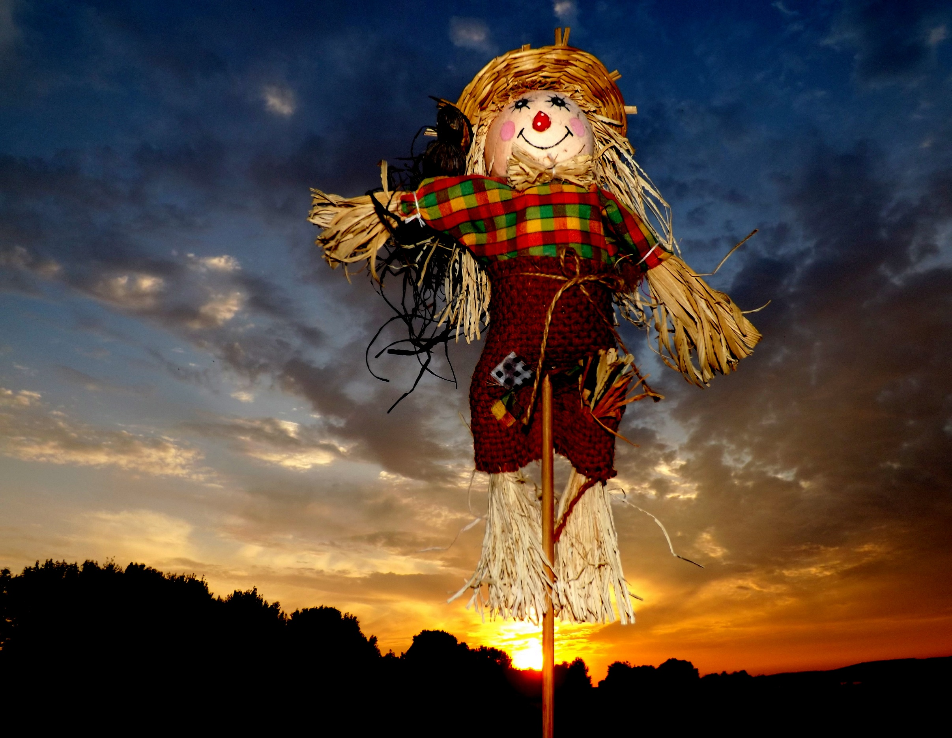
Flu Shots, Venders, Give-a-ways,
Health information
Make plans to attend!!
Saturday October 18th
9:00 am to 1:00 pm
Roosevelt County Fairgrounds Pavilion
Peanut Valley Festival Health Fair
In Conjunction with the Peanut Valley Festival

